Home Automation Hub for Monitoring and Controlling Living Conditions

**Project Group 9**

Jacob Dorpinghaus, ECE

Benjarit Hotrabhavananda, CE

Matthew Mik, EE

Luke Posey, EE

Prepared for

ECE 3110 – ECE Projects Lab, University of Missouri

September 11, 2018

***Abstract –*** In the home automation hub, the user has the ability to view and control room condition variables. The user is able to monitor and control temperature, humidity, and light. The user is able to monitor and adjust the temperature based on manual settings, living patterns, and daily absence of the home. The user is able to monitor and adjust the humidity in the same fashion as temperature. And finally, the user is able to view room lighting and turn off lights either manually or again automatically based on absence from home.

***Index Terms –* Centralized control, microcontrollers, environmental monitoring, electric sensing devices, temperature measurement, humidity measurement, air quality**

**Introduction**

(By: Luke Posey)

The project is a home automation project aimed at providing digital control of various living conditions. The project encompasses a central hub capable of monitoring and controlling conditions usually only monitorable and controllable from their respective locations. Variables initially intended for monitoring are temperature, humidity, lighting, and air quality. Along with lighting capable of being controlled from the central hub. Temperature, humidity, and air quality will trigger alerts at certain determined levels/limits. The project is a proof of concept for the central hub capability and may evolve into remote control from a mobile device or web interface. The project solely encompasses central control from the same hub gathering the sensor data.

A central hub allows a home to monitor and control variables from one central location rather than having to purchase monitoring devices separately and cause unnecessary confusion. The hub could be extended to turn on dehumidifiers, trigger thermostat to control the heating accordingly.

At present, most home and area owners must manually change values and oftentimes do not monitor values like humidity and air quality. The central hub facilitates a centralized location for being fully aware of one’s living conditions.

**System Diagram**

The central control unit simply interfaces with various inputs and outputs to provide intuitive home control mechanisms. Various sensors act as the inputs and LEDs and a touch screen display act as the output for the sensor values as well as means of controlling appliances.

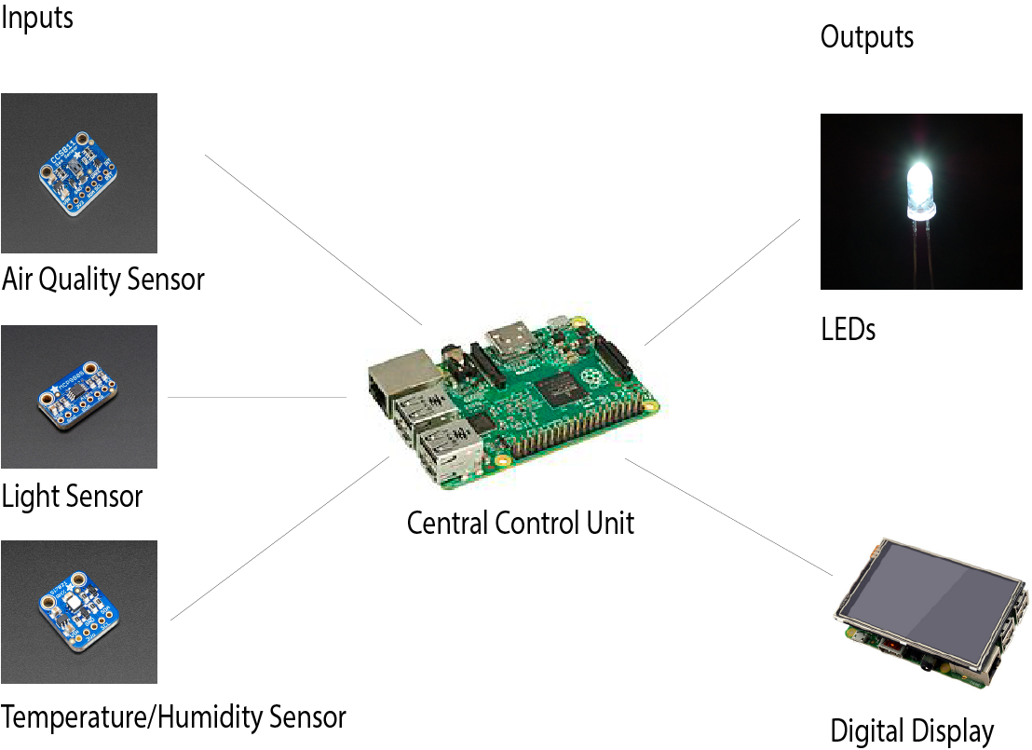

**Figure 1. Home Automation System Diagram**

The system consists of a number of sensors providing input to the central control unit which outputs values for light, air quality, temperature, and humidity to the display. The touch-screen display is capable of controlling and overriding appliances to adjust input values.



This mockup of the interface for the display (output) connected to the Raspberry Pi showcases the monitoring capabilities of the sensor inputs. It was created by the writer using the technology stack the group intends to employ.

**Functional Block Diagram**

By: Matthew Mik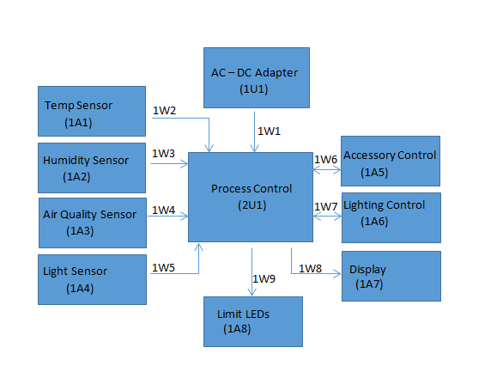

**Figure 2. Functional Block Diagram**

The Temp Sensor assembly (1A1) detects the temperature of the room and gives digital output signal (1W2) which is used as an input for the Process Control unit (1U1).

The Humidity Sensor (1A2) detects the humidity of the room and gives digital output signal (1W3) which is used as an input for the Process Control unit (1U1).

The Air Quality Sensor (1A3) is a gas sensor that detects many volatile organic compounds in the room and gives digital output signal (1W4) which is used as an input for the Process Control unit (1U1).

The Light Sensor assembly (1A4) detects if lights are on and gives digital output signal 1(W5) which is used as an input for the Process Control unit 1(U1).

The AC-DC Adaptor (2U1) allows for AC power to be converted to DC to the desired voltage, outputting the power signal (1W1) which is an input for the Process Control unit (1U1). The Process Control unit (1U1) is a raspberry pi that will control all of the digital inputs and power input stated and gives digital output signals (1W6) and (1W7). It also has input signals (1A5) and (1A6) which will be digital signals about what the desired change in temperature, humidity, air quality, or lighting is.

The Accessory Control assembly (1A5) receives digital input signal (1W6) and will be how the user changes the temperature, humidity, or air quality of the house through the use of triggers.

The Lighting Control assembly (1A6) receives digital input signal (1W7) and is how the user changes the lights either by triggers or by timers.

The Display assembly (1A7) receives digital input signal (1W8) and displays the current temperature, humidity, air quality, and if the lights are on.

The Limit LEDs assembly (1A8) receives digital input signal (1W9) and will turn on when the temperature, humidity, or air quality is outside of a desired range.

**Table 1. Work assignments for home automation hub functional components**

|  |  |  |
| --- | --- | --- |
| **Ref. Des.** | **Element** | **Assigned To** |
| 1A1 | Temp Sensor | Luke Posey |
| 1A2 | Humidity Sensor | Luke Posey |
| 1A3 | Air Quality Sensor | Luke Posey |
| 1A4 | Light Sensor | Matthew Mik |
| 1A5 | Accessory Control | Matthew Mik |
| 1A6 | Lighting Control | Matthew Mik |
| 1A7 | Display | Luke Posey |
| 1A8 | Limit LEDs | Matthew Mik |
| 1U1 | AC-DC Adapter | Matthew Mik |
| 2U1 | Process Control | Luke Posey |

_____________________________________________________________________________

**1U1 Software Architecture Diagrams (By: Benjarit Hotrabhavananda)**

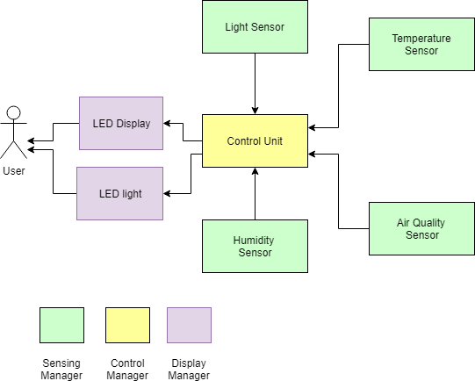

**Figure 1. Software Architecture Diagram**

Figure 1. portrays a manual overview use case for the the integrated Home Automation Hub system. Green boxes represent sensing manager while yellow box represents process management software present on the system’s control unit and dark blue represents a display manager for the system. The systems have sensors which reads the inputs and send those inputs to the control unit. The control unit process the input and controls the device- LED and dehumidifier based on the outputs from the control unit.

Sensing Manager

* LED Displays
  + Display the current status of each sensor and/or motor to the user based on last sent command from control unit.
* LED Light
  + Can be activated or deactivated automatically to indicate the air conditioner is on or off.
* Light Sensor
  + Provides control unit with data of light intensity in a room to determine whether the light in a room should be on or off
* Temp/Humid Sensor
  + Provide data to control unit for interpreting to determine whether the LED light will be on or off and display the data on LED display.
* Air Quality Sensor
  + Provides control unit with air pollution level data to determine whether the LED light will be on or off and display the data on LED display.

Process Manager

* Control Unit
  + Microcontroller, Raspberry Pi, to process all (user) input and output.

(By: Jacob Dorpinghaus) Our central control unit uses several managing processes to analyze data, control the appropriate outputs, and provide useful information to the user. The sensing manager is responsible for reading inputs from each of the environmental sensors, including the temperature sensor, humidity sensor, light sensor, and air quality sensor. The control manager toggles the accessory relays and activates the limit LEDs if the environment values exceed predefined thresholds. The display manager is responsible for relaying useful information to the user by means of a visual display. The values for each of the environmental sensors are displayed in real time.

|  |  |  |  |  |  |  |
| --- | --- | --- | --- | --- | --- | --- |
| **Environment API** | | | | | | |
| **Sensing Manager** | | | | **Control Manager** | | **Display Manager** |
| **Temperature Sensor** | **Humidity Sensor** | **Light Sensor** | **Air Quality Sensor** | **Accessory Relays** | **Limit LEDs** | **Display** |

**Figure 2. Technology Stack Diagram**

**Table 2. Work Assignments for Home Automation Hub Software Architecture**

|  |  |  |
| --- | --- | --- |
| **Technology/Layer** | **Software Element** | **Assigned To** |
| Device Driver | LED Display | Benjarit Hotrabhavananda |
| Device Driver | Temp Sensor | Jacob Dorpinghaus |
| Device Driver | Humid Sensor | Benjarit Hotrabhavananda |
| Device Driver | LED Light | Jacob Dorpinghaus |
| Device Driver | Light Sensor | Benjarit Hotrabhavananda |
| Process Manager | Control Unit | Jacob Dorpinghaus |
| Display Manager | Graphical User Interface | Luke Posey |

**Safety Issues**

By: Matthew Mik

We need to be careful of the polarity of any connections that are made to avoid having too much voltage. We also need to be careful of short circuit situations as well, as they can lead to overheating and potentially fires.

**Process Timeline**

By: Matthew Mik

